Western Michigan University

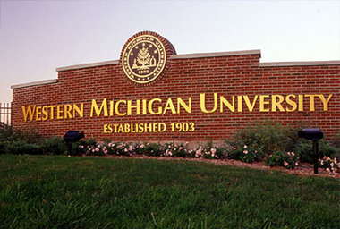
Steam Trap Management Program

Statement

The W.M.U. Facilities Management Department is responsible for more than thirteen miles of underground steam and condensate lines, including more than two miles of utility tunnels that are divided into 4 steam zones and 6 condensate zones with 4,430 steam traps. The dedicated program employs wireless trap monitoring and detailed reporting analytics to maintain peak efficiencies.

The Steam Trap Management program has achieved highly successful results for 23 years, reducing natural gas consumption and carbon emissions, as well as the campus-wide steam trap failure rate. Currently, W.M.U.’s steam trap failure rate is less than three percent compared to an industry failure rate of twenty percent.

The program runs annually from October through June, and has one, dedicated full-time hourly employee, and a student support team. It relies on three methods for testing steam traps, which include yearly manual tests, monthly wireless vault tests, as well as 24/7 wireless tests via the Building Automated System.

The Steam Trap Management program at Western Michigan University enhances service delivery, increases productivity, improves customer service, and generates revenue via cost reductions.

Institutional Benefit

The Steam Trap Management program’s primary goal is energy conservation, which translates into millions of dollars in cost avoidance for Western Michigan University. Other benefits include a reduction in maintenance emergency calls. This occurs because of the constant monitoring of the entire steam system and the components that might otherwise fail, but are instead identified and repaired or replaced. This is also accomplished because many areas of the 8.8 million building sq. footage that often is rarely seen can be inspected while parts of the steam system are being inspected. Premature failures of critical equipment have been reduced and piping lifetimes have been extended, because the steam system is kept at its optimal operating condition by being proactive in addressing the steam system. The increase in heat transfer is another outcome of maintaining the steam system. With less malfunctioning equipment, the steam system can deliver the maximum amount of energy to its designed location. With a portfolio of 151 buildings, including 22 residence halls and 200 campus apartments, faculty, staff, and the more than 25,000 students benefit from a more comfortable environment due to the increased heat transfer efficiency, and fewer distractions because of the reduction in the amount of water hammer noise

The program has also allowed the university to create opportunities for students from the College of Engineering and Applied Sciences. Engineering student interns in the Facilities Management Engineering division now play an integral role in gathering and organizing program data, as well as the administration of associated reports.

Innovativeness, Creativity, and Originality

Now in its twenty-fourth year, the program is the result of a clear vision, dedicated technicians, and a continuous improvement mindset. The program is the oldest of it its kind in the country. In 1988, W.M.U.’s Steam Trap Management program was recognized by the State of Michigan, receiving its prestigious Governor’s Energy Award.

As new technologies have been introduced, the program has adapted to maintain its effectiveness. Wireless steam trap monitoring has increased efficiencies among the front-line service providers. Improved reporting analytics have made possible a more effective and efficient use of time and resources.

Over the course of the last twenty-four years, the W.M.U. Facilities Management department has hosted countless visitors from peer organizations across the country, and around the world, who have come to learn more about the program. Michigan State University, University of Michigan, University of Utah, New Mexico State, Notre Dame, Indiana University, University of Iowa, University of Illinois, along with (19) other universities have sent representatives to WMU to learn about the program and they find out how to implement a similar program at their institution. There have also been representatives from the State of Michigan Department of Corrections, the State of Missouri, many healthcare institutions, and even the People’s Republic of China, who have learned of the success and benefits of the W.M.U. program.

Portability and Sustainability

The reduction in the number of steam trap failures results in significant cost savings. Over the long term, this has an enormous impact environmentally via the reduction of natural gas consumption and carbon emissions. W.M.U. has a campus-wide steam trap failure rate of 2.86%. This is well below the industry average steam trap failure rate of 20%.

The steam trap program is easily adaptable to other institutions, hospitals, and even commercial applications. It makes use of a web-based data management system. The software may be accessed from anywhere in the world where internet access is available, and the history and data collected is all stored offsite so there is no need to purchase or maintain a server. The program’s wireless technology uses an open protocol which enables it to communicate with a variety of Building Automated Systems, such as Lonworks, Bacnet, and Modbus to name a few. The software is very inclusive, and works with different types of traps, from a variety of manufacturers, in several diverse applications. Additional equipment the program requires to test the steam traps is readily available and relatively inexpensive. Many of the higher learning institutions and other, organizations that have visited and learned about the Steam trap management program at Western, have since started their own programs based on the W.M.U. model.

Management Commitment and Employee Involvement

Support for the Steam Trap Management program comes from all levels of the university. W.M.U. has had three vice-presidents for business & finance over the life of the program, and all three have expressed an unwavering commitment to it, often employing the phrase “going green saves us money.” Active employee involvement has been a key to the program’s success. The Key has been having buy-in on all levels of the program. From management who see what the financial gains are from having this program implemented, to the technicians who test the traps and who believe in the program and take ownership of the steam trap testing and steam trap management program. On-going collaboration between technicians, department managers, and senior leadership ensures the program’s continued development well into the 21st century and beyond.

A video of the senior management commitment to the program can be found by following this link: http://www.screencast.com/t/fiwbDVQB

Documentation, Analysis, Customer Input, and Benchmarking

The W.M.U. campus has 4,430 total steam traps. Initially, more than 1,000 steam traps were failing on an annual basis. Today, that number has been reduced to just above 100.

The wireless monitoring system tests the traps 24 hours a day and 7 days a week. This setup is used on campus in hard to reach locations on high pressure high dollar applications. Here a device is connected downstream of the steam trap on the condensate pipe, and it monitors the steam trap’s cycling. This information is transmitted to a receiver that is tied to the Building Automation System where it is tracked, and in the event of a steam trap failure, the BAS notifies the appropriate technicians and management staff via e-mail or pager. A video WMU created to demonstrate this process can be seen here (http://youtu.be/bAqDLHbLGxM). This video shows one of the SteamEye and steam trap setups in WMU’s Paper Pilot plant.
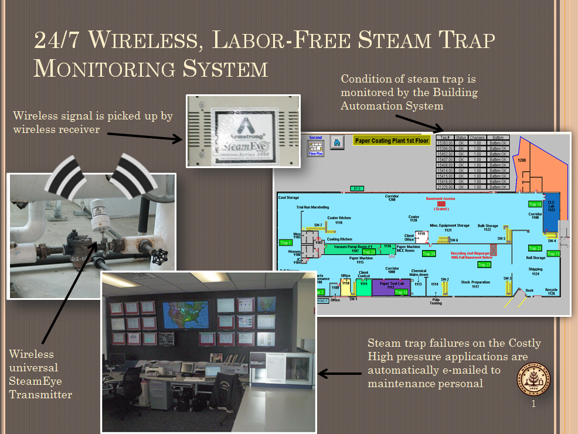

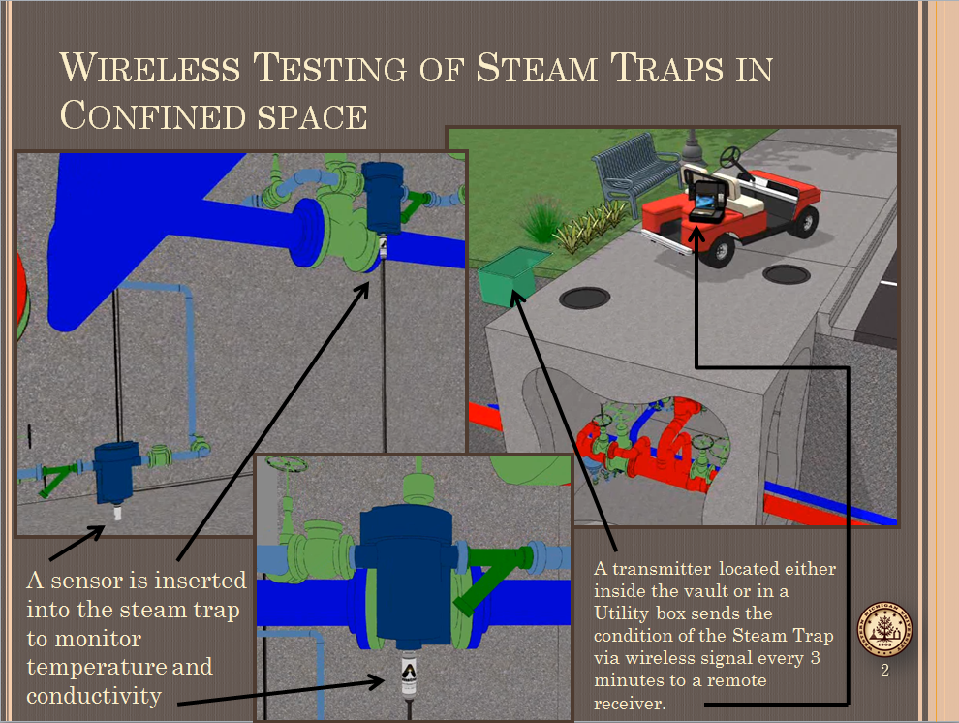
In confined space applications that require two technicians and several hours to test the steam trap such as the one seen here (http://youtu.be/a7eoITpIHyM), a sensor is inserted into the steam trap to monitor the temperature and conductivity of that trap. A wireless signal is sent from a transmitter from either inside the vault or near it in a utility box, to a mobile receiver that can be easily transported around campus. The signals are sent every three minutes which allows for the testing of several underground vaults in under an hour as opposed to an entire work day. Two videos showing two of WMU’s vaults that has this technology can be seen here (http://youtu.be/ghlOhJrs5SU) and here (http://youtu.be/86rETlzS5Qo).

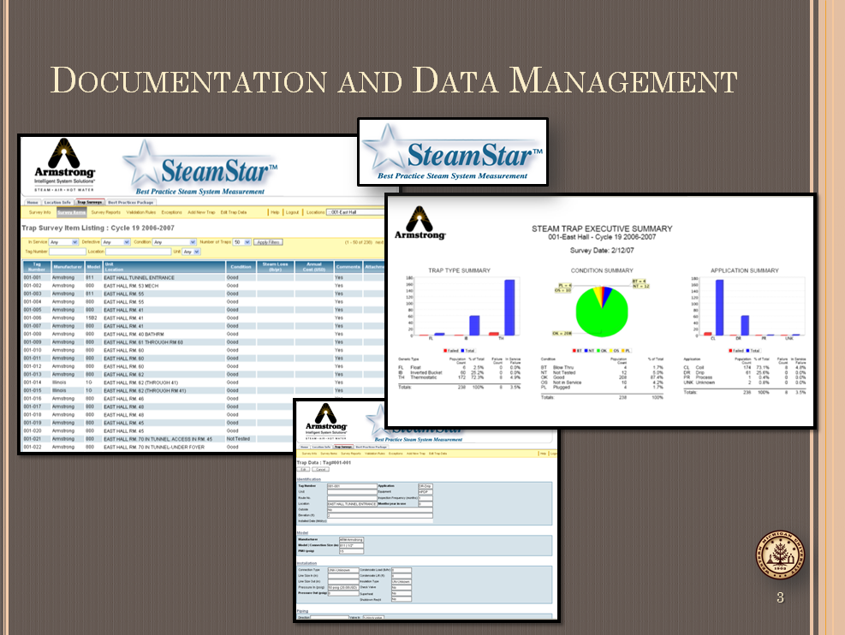
WMU uses Armstrong International’s SteamStar product to store, archive and manage steam trap data. The information is stored by Armstrong who also maintains the servers. WMU has a username and password to access the information from anywhere internet access is available. Using this software the emissions in relation to wasted steam can be monitored, the dollar amount of the failed steam traps are wasting, problem areas can be identified, and reports can be generated to show emissions, monetary loss, BTU loss, and trending analysis can be performed.
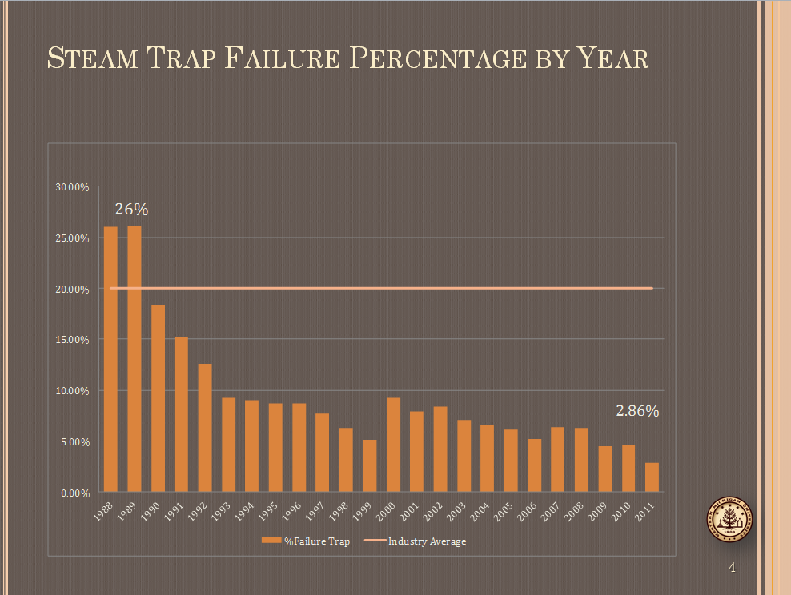
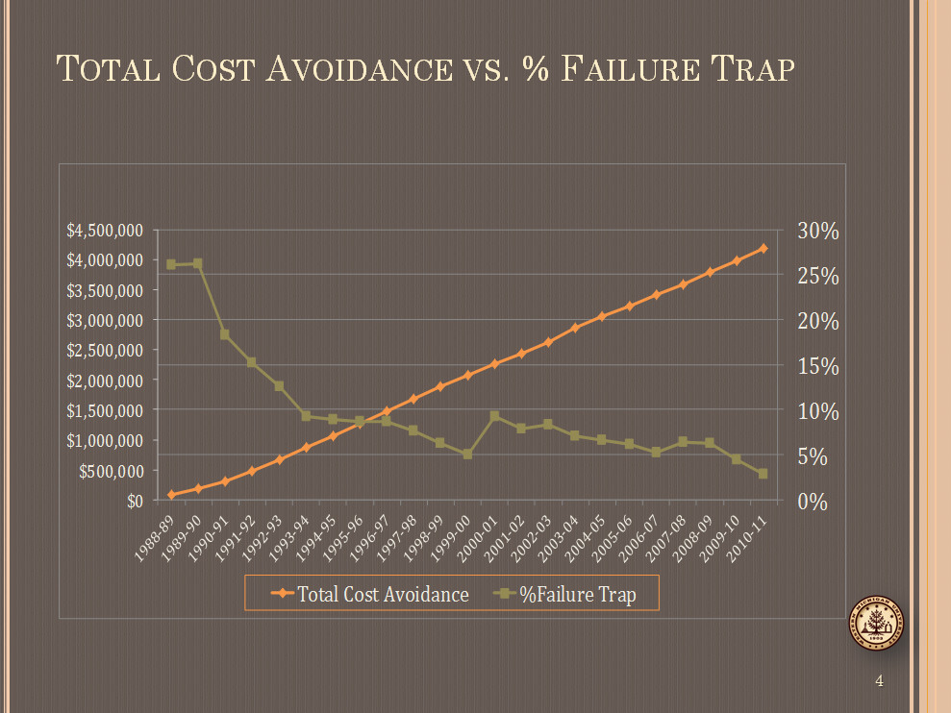
$4,179,181
2.86%
26%

