**APPA Effective and Innovative Practices**

**The University of Texas at Austin Facilities Services**

**Warm Up Program for Custodial Services**

Facilities-logo-PMS_tiny.jpgCustodial Services in the Facilities Services Department at The University of Texas at Austin is doing more than keeping buildings in top shape. As time goes on, many of us find it harder to stay healthy. With hectic schedules we often forget to take care of ourselves. Recently, Custodial Services brought focus to the well-being of its employees by taking a few minutes to prepare them physically and mentally for the start of their work day.

The United States Department of Labor statistics for 2010 found seven occupations with the highest level of injury rates in the United States. Custodial and janitorial workers rank third on the list, with a majority of the injuries attributable to strains and sprains due to overexertion. See <http://www.bls.gov/news.release/osh2.nr0.htm>. These findings are consistent with our experiences for the past few years, and we began looking for opportunities to reduce these trends in our workforce.

**FIT Start Warm Up Program**

In fall 2010, Custodial Services began working with the university Kinesiology Department’s Fitness Institute of Texas (FIT) to create a program specifically for our custodial staff. Following a few visits with FIT staff we embarked on a cooperative effort to develop and implement a program aimed at reducing workplace injuries.

Development included looking at job descriptions for each function performed, then interviewing and observing our staff in action, and finally running trial programs to see what did and didn’t work for our staff. The goal of the warm up program is to prepare our employees for the demands of the job and help reduce the risk of injury. According to the Kinesiology Department, injuries can occur when our bodies are not ready to do what the job requires.

A warm up is helpful in two major ways:

1. It gets blood to our muscles that are needed for the activity or job demands. This movement of blood also warms up our bodies.
2. The warm up increases the communication between our brain and our muscles, which reduces the risk of injury. A warm up begins the communication process in an orderly manner that allows our muscles time to prepare for activity.

Once the basic movements were selected, collateral material was developed: a program booklet and posters that clearly illustrate the movements. (See attachments.) The booklet illustrated the movements and described what muscles were being warmed up. Steps for each movement were explained to assist in implementing the program and as refresher material available at any time. The posters were placed in areas where the warm ups would be performed as a ready reference while the warm ups were taking place.

The material included a name for the program that embodies its intent: to make our employees” fit” for duty each shift and to remind us that the warm ups would occur each day at the “start” of the shift. Hence the FIT Start Program was christened.

**Training the Trainers**

The next phase of the project was to train our supervisors to train their employees. One distinction that had to be understood was the difference between warm ups, stretching and exercise. Trainers needed to understand that FIT Start movements are not stretches or exercises. Further, they are not difficult, take only a few minutes to complete and will not make anyone sweat. Mark Faries, M.S., Kinesiology Department doctoral graduate assistant, led two train-the-trainer sessions for each shift of Custodial Services trainers.

**Program Roll-out**

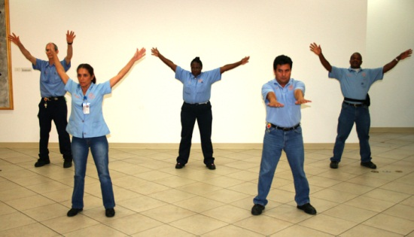To roll the program out to all of our 342 custodial employees we again used the talents of Mark Faries to explain the value of the program. Having a professional from an academic department involved in the roll-out was significant, as our staff immediately accepted FIT Start as a professional program designed especially for them. We have also found that our staff responds well to anyone affiliated with the university’s athletic programs.

Each employee received collateral material to take home, as it not only covered information pertaining to the FIT Start Program but also included valuable information about nutrition and healthy lifestyles. This was done in an effort to complement employee health initiatives sponsored by the university’s Human Resource Department.

The program was received positively from the start. In an environment that has included some budget reductions that can be a detriment to employee morale, a program that is all about caring for the health of the individual employee has exemplified the importance that the university places on each individual staff member.

The movements are a mandatory function; however, range of motion is dictated by the individual, with encouragement to do as much as is comfortable. Each crew is evaluated on how well they are doing with the program. Custodial Services has a 512-point internal audit that includes five items related to the Fit Start Program:

* Supervisor is willing to lead warm up movements.
* Supervisor encourages reluctant employees.
* Supervisor stresses the importance of the warm up movements and corrects form.
* Supervisor conducted warm ups in appropriate time frame.
* Supervisor can articulate worker’s feelings towards the warm ups.

**Employee Surveys**

To gauge how the program was being received and detect whether adjustments might be needed, we surveyed employees. The initial survey took place two months following the program roll-out. We received responses from 61% of the workforce, with these results:

* 84% were “kind of” to “very willing” to perform the FIT Start warm-up movements.
* 85% found the movements “easy” to “very easy” to perform.
* 76% saw FIT Start movements as benefiting their performance and health while at work.
* 66% viewed these movements as benefiting their performance and health outside of work.
* 81% believe that the university is doing the right thing by initiating the FIT Start program.

Comments ranged from the enthusiastic to the skeptical. One employee wrote, “I absolutely love it! It helps to get my blood flowing faster through my body to tell my body it's time to work. Very good program!” On the other hand, another said, “I believe it is a waste of time.”

After conducting the program for six months, Custodial Services again surveyed employees about the effectiveness of FIT Start. We received responses from 83% of our workforce, with these results:

* 82% viewed the difficulty of these movements “easy” to “very easy.”
* 55% would like to see changes to the movements.
* 75% saw FIT Start movements as benefiting their performance and health while at work.
* 62% viewed these movements as benefiting their performance and health outside of work.
* 73% believe that the university is doing the right thing by continuing the FIT Start program.

Comments again ranged from mostly positive to some that were less enthusiastic. One employee wrote, “It’s great because it keeps you healthy and the exercises are described well!”  Another said, “Perhaps more traditional stretching exercises would be beneficial.”

Following are the results of both surveys:

**How difficult have these movements been for you to perform?**

**Have these movements benefited your performance and health while at work?**

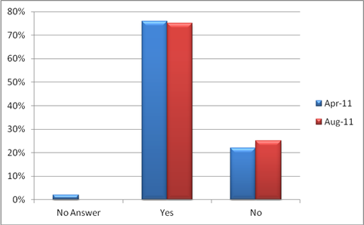

**Do you believe UT is doing the right thing by continuing the FIT Start program?**

**How hesitant are you to perform the Fit Start warm-up movements?**

**I**

**Would you like to see changes to the movements every couple of years?**

The response rate was extremely high for both surveys. Responses were largely positive, with some comments noting life-changing results. We will issue another survey at the one year anniversary of the program, with emphasis on feedback about revisions for the coming year. Custodial Services and Kinesiology we will revise the program annually to keep it fresh and address current needs as determined by accident occurrence and types.

**Reducing Accidents**

While accident rates and lost time injuries have remained static since implementation of the program, it is important to note that Custodial Services has experienced reductions in staff and increases in cleanable square footage during this timeframe. We would expect injuries to increase as a result. They did not.

**Supporting Facilities Services’ Goals & Values**

One of the strategic goals of Facilities Services is to have a highly motivated, well trained, stable workforce. Bringing a program to our staff that promotes wellness and physically gets them ready for their shift each day has been motivating, and reducing the possibilities of accidents will create additional stability in the workforce.

The core values of Facility Services are service, integrity, teamwork, excellence and stewardship. This project supports the values in the following ways:

**Service:** The FIT Start Program enhances wellness in our workforce, resulting in better customer service on a daily basis as more custodians are available and ready to perform to the best of their abilities.

**Integrity:** The program illustrates the university’s commitment to each employee by creating a program meant to enhance the employee’s wellness both at work and at home. By making each employee responsible for doing the movements to the best of his or her abilities, the program relies on the integrity of the individual.

**Teamwork:** The FIT Start partnership between Custodial Services and Kinesiology demonstrates the benefits of creative collaboration in problem-solving. Performing the FIT Start movements at the beginning of each shift enhances teamwork and daily performance of the group.

Custodial Services and the Kinesiology Department came together to present the FIT Start material at the National OS1 Users Group Symposium in Salt Lake City in July 2010. Both organizations also worked with ManageMen (OS1 parent organization) to reach an agreement to roll out the FIT Start Program under the title “OS1 Team Warm-ups”. The program is now an official part of the OS1 Process utilized by many universities and other organizations across the United States.

**Excellence:** This creative approach addresses the work and personal health needs of staff members who are at a greater risk of injury than many employees. It illustrates the desire to seek continuous improvement at all levels in the organization.

**Stewardship:** By seeking help within the university to solve a problem, Custodial Services reduced costs and created a partnership in which continuous improvement to the program can be expedited. Both organizations benefit from the project as custodial employees enjoy a healthier life and the Kinesiology Department gains expertise in a new area. Additionally, employees gain awareness of the personal and organizational value of stewardship.

**Institutional Benefit**

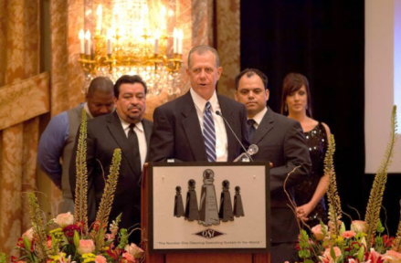The university has benefitted from this program in several ways. The Kinesiology Department had never worked with another organization to develop a program for the organization’s employees, nor had they worked under contract with an individual component of the university to achieve a goal directed at only that component’s employee base.

The program was recognized with The Best Cleaning Industry Safety and Health Program Award at the National OS1 Users Symposium in 2011. Having the program adopted by and for OS1 Users across the nation also recognized the efforts of Custodial Services and the Kinesiology Department.

An unexpected form of recognition has been the attention of non-custodial workers across campus. In several instances administrative employees have asked if we could do something similar for their group.

**Innovation, Creativity, and Originality**

Leadership within Custodial Services realized that workplace injuries were an issue with our employees and sought a way to address the issue. The university’s Worker’s Compensation Program provides healthcare and reduced duty for workers who have been injured. However, we wanted to get in front of the injury management process by reducing the occurrence of injuries instead of only managing them after they occurred. It would have been relatively simple to create a generic stretching or exercise program, but by involving the right people we were able to provide a program specifically designed for our workforce.

**Portability and Sustainability**

This type of program can be replicated and adapted to address any regional or occupational differences. Adoption of the program by the OS1 Users indicates that any regional differences are easily overcome. Although the Kinesiology Department had no previous experience with custodial staff, they learned through observation, evaluations of our physical demands information, and meeting with various staff across the organization. This same method could be utilized to create programs other positions.

Although the warm ups would be effective as they are, we will continuously seek improvement to keep the program fresh and enjoyable and to maintain the most effective program possible.

**Management Involvement and Employee Commitment**

From the initial meetings with Kinesiology staff through evaluation of employee surveys, Custodial Services management has driven this project. Ongoing commitment of each level within the Custodial Services organization is evident in the daily participation of more than 300 individuals. From auditors that assure each crew remains in compliance, to crew leaders who lead the warm ups, to custodial employees who start their day, every day with the FIT Start Program, commitment is there.

The level of response to our FIT Start surveys has been phenomenal. Many surveys are considered successful if 20% of the solicited group responds. Custodial staff responded at 61% in the initial survey and 83% in second survey. While the vast majority of those surveyed were positive about the program, even the minority that responded negatively to the program did respond, illustrating the impact that the program has had and the level of interest and commitment of staff.

**Documentation, Analysis, Customer Input, and Benchmarking**

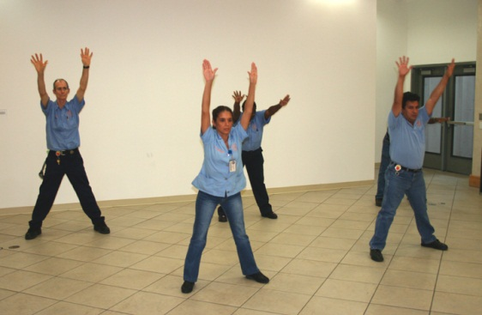Custodial Services was fortunate to have solid documentation relating to the physical demands and specific movements required to perform custodial work prior to contacting the Kinesiology Department. The analysis Kinesiology performed to establish what movements were needed to warm up the specific muscles we would utilize for each task is a component of their academic body of knowledge.

As this is the only program of its kind of which we are aware, future benchmarking will likely consist of assessments of other organizations that have adopted the program through their OS1 affiliation.

Customers for this project were the more than 300 custodial staff members. As demonstrated by the survey responses, the feedback loop has been quite robust. Employees have provided valuable input throughout the project. Their suggestions were added to the training for the benefit of others. In what has been one of the indicators of the success of the project, many of the newly trained employees have begun to further their wellness programs on their own, and many have made comments regarding how their health has improved.