 

**Statement of Program/Practice and Results**

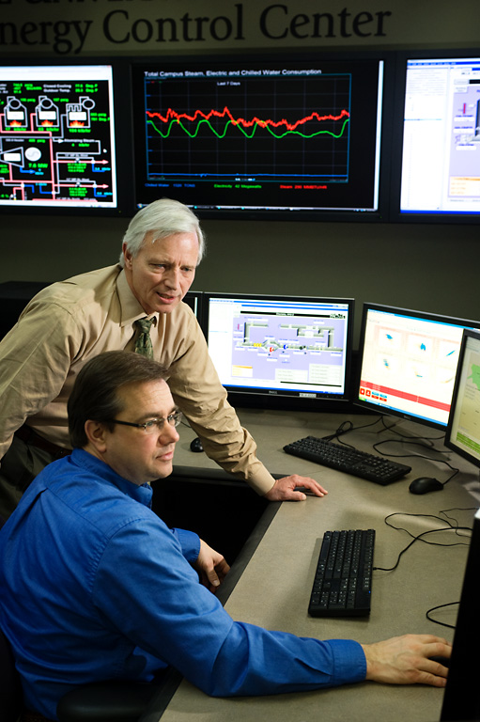How do you streamline energy usage and production across some 17 million square feet of the University of Iowa (UI) campus while reducing both costs and the university’s carbon footprint? UI Facilities Management developed an innovative solution that addresses these challenges--and has the potential to achieve even more.

The UI’s Energy Control Center houses one of the most advanced and extensive energy management tools available in a campus environment.

The UI’s Energy Control Center (ECC) represents the next generation in energy management. Reaching far beyond the scope of a typical control center, the ECC serves as a highly advanced and integrated hub for monitoring, analyzing, and forecasting energy supply and consumption.

The ECC simultaneously monitors energy data from over 100,000 collection points with the goal of translating it into actionable information. Historical data is correlated to weather data to create real-time predictions of energy consumption. This powerful tool enables engineers to make critical decisions about equipment usage and energy purchasing and empowers maintenance staff to move from responsive to predictive maintenance.

Since April 2010, the ECC has revealed well over $500,000/year in energy savings while enhancing customer communication and occupant comfort. With “building dashboards” of real-time energy consumption available to occupants, the UI is well on its way to empowering the campus with the next generation of energy management tools.

**Institutional Benefits**

The Energy Control Center (ECC) is part of an ambitious campus-wide effort to reduce overall energy consumption 15 percent by 2013 and to consume less energy on campus in 2020 than consumed in 2010 despite projected growth. The ECC has been propelling the University of Iowa toward its energy conservation goals by providing readily accessible production and consumption data that can be reviewed as part of an integrated dynamic system. This advancement better equips Facilities Management to focus on the university-wide mission of sustainability and to help identify and correct maintenance challenges before the customer is even aware there is a problem.   
  
The ECC is the next generation in energy management tools going well beyond monitoring to the science of optimization. The Energy Control Center is powered by a cutting-edge, real-time modeling software called VantagePoint EEM (Enterprise Energy Management) developed by Rockwell Automation. The UI further collaborated with Rockwell to include Energy Star Benchmarking and automated equipment exception reporting making the UI project the first full-scale application of the software.

**Optimizing Production**The ECC enables plant operators to optimize the production of steam, chilled water and electricity using cutting-edge, real-time modeling software. This software predicts steam and chilled water loads 12 hours in advance and recommends the most cost-effective dispatch of boilers, turbines and chillers to meet that load. This information also enables energy engineers to make valuable decisions about real-time and spot market energy purchasing based on price and availability.

“Through the Energy Control Center, we have the opportunity to continuously improve our sustainability performance, reduce our greenhouse gas emissions and our energy costs, and to lighten our environmental footprint,” says Liz Christiansen, director of the UI Office of Sustainability.

**Optimizing Demand**The ECC provides accurate baselines of how buildings consume energy under all temperature and humidity conditions. Energy engineers use these baselines to identify unexpected changes in building energy consumption and to verify energy savings from energy efficiency projects.

**Predictive Maintenance**Focusing on predictive maintenance and system optimization creates a more comfortable and efficient work environment while helping the UI save energy dollars. The ECC has helped to uncover irregularities in the UI’s steam-distribution and chilled water systems, saving the UI months of troubleshooting and countless staff hours. Instead of relying on customers to call and notify Facilities Management of problems like “It’s too hot” or “the air handler is not working,” energy engineers are now able to detect problems on the screen before the customer experiences discomfort.

**Building Dashboards**  
Recently launched “building dashboards" display real-time energy consumption, allowing building occupants to access and view their energy consumption and utility costs for their campus building online anytime and from anywhere. This dashboard capability provides immediate feedback to building occupants on energy conservation efforts and helps them become active participants in the UI’s goal to reduce energy consumption.

**Characteristics or qualities that make this program or practice different or innovative**

**State-of-the-art hub/centralized information**

* Serves as a centralized location to simultaneously monitor energy data for both the supply and demand sides of the campus, utilizing over 100,000 data collection points (pressure, temperature and flows) from 82 buildings and utility systems across campus.
* Visualization of production and consumption data on-screen and in real-time, along with access to historical data, provides for advanced troubleshooting and analysis..
* Integrated data and tools expedite consistent and accurate responses to requests for information.

**Real-time predictions of energy consumption**

* Historical data is correlated to weather data to create real-time predictions of steam, electric and chilled water loads for every building on the campus utility systems, 24 hours in advance.
* Predictions can be used to decide which chillers, boilers and turbines to use in advance of their need, which, in kind, provides for better strategies in purchasing and utilizing raw energy such as coal, biomass, natural gas and electricity.
* Predictions alert energy engineers to unexpected increases in building energy usage and verify and quantify savings from energy-efficiency projects.

**Benchmarking**

* Software automatically evaluates every building against Energy Star benchmarks monthly.

**Automatic monitoring of building systems**

* Software is linked to building control systems and automatically monitors key parameters to identify energy-wasting conditions. For instance, this software can detect leaking steam and chilled water valves in air handlers, which can be large sources of wasted energy.

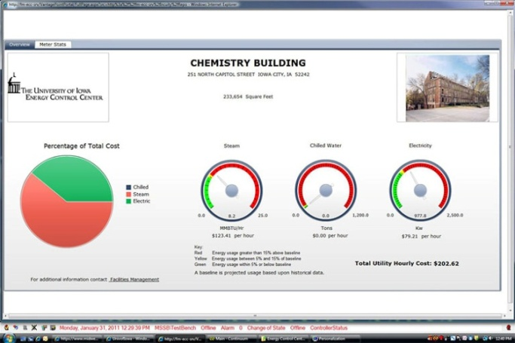**Building Dashboards**

* Provides on-line, real-time displays of energy usage and costs for all of the buildings connected to the campus utilities system. Offers immediate feedback to building coordinators and occupants to help spur behavior change. Gauges dynamically show how current usage compares to baselines given current temperature and humidity. <http://facilities.uiowa.edu/uem/energy-management/ecc-bldg-dashboard.asp>

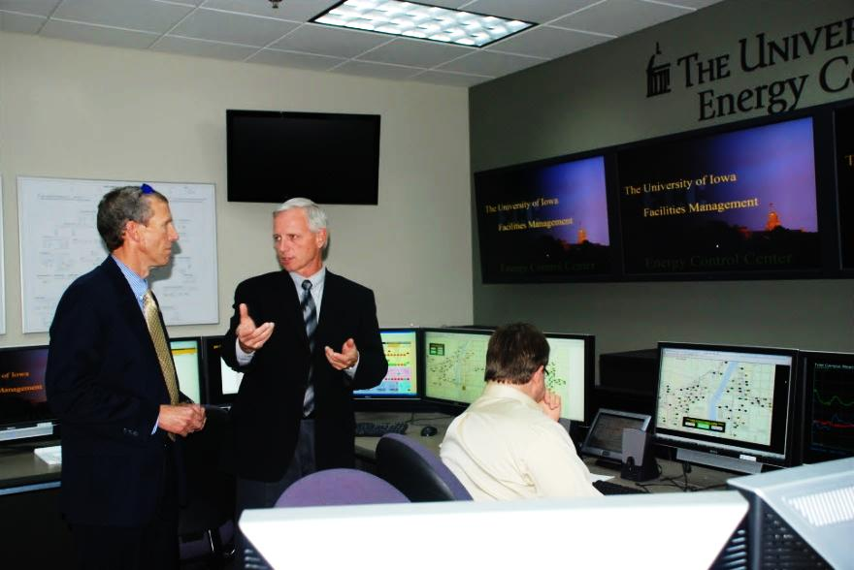**How this practice can be used by others**

The ECC and its overall concept is being studied and adapted for use by other institutions. Since opening, the ECC has hosted over 75 tours for visitors from other universities, organizations, and federal and state governments, including the EPA regional administrator, the current and a former Iowa governor, and U.S. congressmen. Energy Control Center staff have also presented at national conferences and shared their knowledge in the classroom.

* **Understand your institution’s production and consumption.**  The first step to success with any energy conservation effort is to thoroughly understand how your institution produces and consumes energy. It’s a well-known fact that you can’t control what you don’t measure. Evaluate historical data on both the supply side and the demand side and study how they impact each other.

EPA Regional Administrator, Karl Brooks (left), tours the Energy Control Center with Glen Mowery, director of Utilities & Energy Management.

* **Invest in the right software and people.** Analyzing multi-layered sets of data from numerous collection points requires the integration of an advanced software system. The UI worked with Rockwell Automation to develop one of the most advanced and extensive energy management software tools available in a campus environment. The interpretation of that information requires staff trained to utilize the available tools and the initiative to develop future possibilities.
* **Create visual interpretations of data.** The integration and visualization of complex sets of data and information is one of the most valuable features of the ECC. The ECC has four large, flat-screen television monitors mounted side-by-side on a wall above a large, U-shaped desk with another dozen smaller monitors. The screens offer real-time displays of information, including schemata of boilers and water chillers with their current operating capacities; real-time energy usage and costs for steam, electric and chilled water; and weather data. In addition, providing a visual tool for building occupants in the form of a “building dashboard’ is critical to gaining their understanding, feedback and support to reduce energy consumption.
* **Bring energy engineers and building operators together.** Having a readily available and integrated source of information for energy engineers and building operators alike helps challenge the current understanding of building systems and enhances teamwork between groups. When resources collaborate they often discover savings in unexpected places.
* **Benchmark.** With historical and real-time information easily accessed from one source, benchmarking is simplified. This centralized source also provides for a more consistent and uniform response to requests for information.

**Demonstration of management involvement and employee commitment**  
Endorsed by UI President Sally Mason and recognized in a UI - EPA partnership, the ECC will play an integral role in delivering on the UI’s aggressive goals of reducing overall energy consumption by 15 percent and becoming a net-negative energy user, despite rapid growth, by 2020.

The $500,000 ECC had been in development for several years, but a $483,500 grant appropriated through the American Recovery and Reinvestment Act of 2009 helped accelerate the project. The remainder of the cost was funded by the UI. Early estimates indicate that the ECC paid for itself through energy savings and cost avoidance within the first several months of operation.

“The Energy Control Center promotes cross-functional teams. Successful energy management programs require collaboration at all levels,” Don Guckert, associate vice president, Facilities Management says. “It’s a paradigm shift — we’re changing the mentality of how we do business.”

The UI began laying the groundwork for the Energy Control Center in 2005 by upgrading building and controls metering across campus. Careful planning over several years provided for the development of infrastructure needed to support the advanced technology of the ECC.

The ECC is currently staffed by one full-time utilities systems specialist and several students from the College of Engineering. In addition, energy engineers and building systems teams work together to utilize the tools available in the ECC. Staff can access information about multiple building systems, critical alarms, and a building’s energy consumption and costs 24 hours a day.

Establishing the ECC illustrates the UI’s commitment to efficient and environmentally friendly energy use, but it also will enable Iowa to lead in energy education and economic development by providing a learning laboratory, says Barry Butler, UI provost and former dean of the College of Engineering.

“Students will be able to gain experience in energy design and systems management here at The University of Iowa in the Energy Control Center. We’ve positioned ourselves as a leader in biomass energy; now we’ve got to bolster the talent,” Butler says.

Facilities Management staff are working with faculty and students in the College of Engineering on a variety of projects, including boiler optimization and data mining to optimize discharge set points on air-handling systems.

The ECC has also provided a valuable tool to UI building coordinators, who now have the ability to access information about energy consumption and costs in their building(s) 24 hours a day via the online building dashboards. Building coordinators are encouraged to display the dashboards in a central location within the building. Building coordinators help facilitate communication to the occupants of their assigned building(s) regarding energy conservation strategies and results.

**Documentation of results, analysis, customer feedback, and resulting benchmarks**

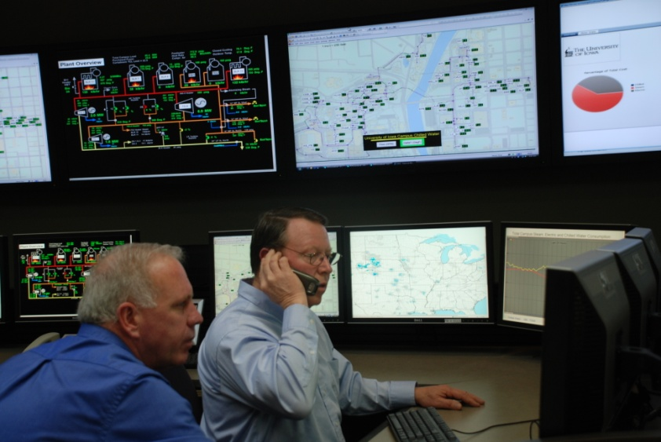While some of the benefits of the ECC will no doubt result in sizeable long-term paybacks, there are already a number of favorable outcomes with respect to energy savings, performance, maintenance, improved occupant comfort and enhanced communications.

* Revealed an opportunity with pressure reducing valves (PRVs) to produce more electricity using less steam, resulting in 600 kW of additional electricity cogeneration with cost avoidance of approximately $200,000 per year.

Real-time displays of energy usage for all buildings connected to the campus utilities system are monitored and evaluated by energy engineers.

* Identified improperly functioning air handlers, which, after repair, resulted in energy savings and increased occupant comfort.
* Led to improved efficiencies in chilled water functioning, including a new method for identifying improperly functioning control loops. This improved process resulted in more efficient systems and reduced wear and tear in the chilled water distribution systems.
* Statistical baselining of building performance uncovered a conflict between occupancy schedules and overrides that had increased energy consumption in the College of Nursing Building. Statistical benchmarking of all buildings provides the capability for tracking utilities for the last 10 years to more readily uncover irregularities.

“We believe ours is the most advanced, integrated and comprehensive energy control center in higher education,” said Glen Mowery, director of Utilities and Energy Management.

* Facilitated increased communication and understanding with customers. With the implementation of the building dashboards, customers call when they have questions, and this in turn provides an educational opportunity with building coordinators and occupants.
* Simplified access and centralized data has led to more accurate and uniform responses to requests for information from customers, funding sources and media.

The future of the Energy Control Center lies in its exceptional capacity to serve as both an emergency control center and work control center, bringing energy conservation, maintenance and operations together into one highly integrated and efficient environment.