**2012 APPA Effective & Innovative Practices Award SUBMISSION**

**Removing/reducing the size of the bin has created less trash, more recycling, efficient housekeeping and a “greener” UNC Charlotte campus**

**Statement of Program / Practice**

**About the Program**

The idea to remove trash cans from all the classrooms and reduce the size of the trash bin in all the offices grew out of meetings as our department developed ways to increase efficiencies for housekeeping while increasing recycling rates. Working together, Housekeeping and Recycling created a fundamental shift in our operations by taking the focus off the trash and putting it on resources and recycling.  Everyone on this campus participates in the program by bringing their trash and recycling to a central location. This simple shift has increased recycling of bottles and cans in all academic buildings by 25% over the last 2 years and increased office recycling by 10-15%in the last few months. Each person at UNC Charlotte is an integral part of the team and essential to creating a GREEN campus.

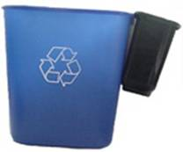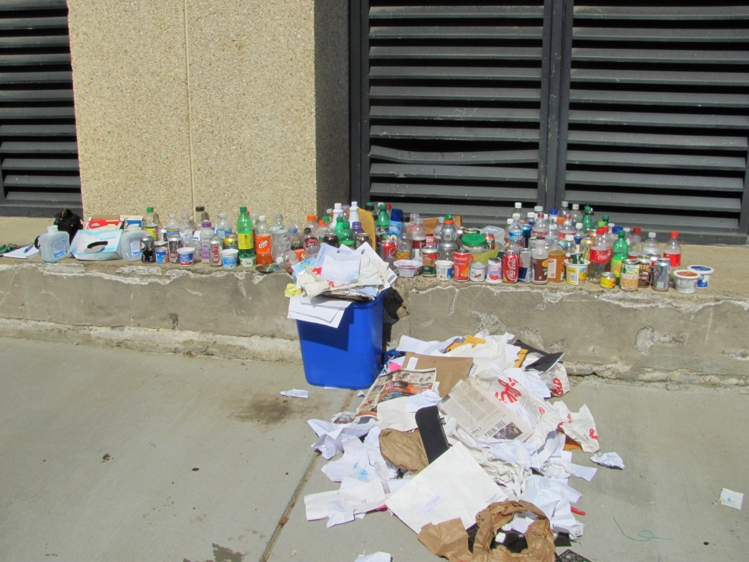

New Mini trash bin given to employees

This is recyclable material found in one day of trash at our library

**Institutional benefits**

As with most colleges around the state, and country, deep budget cuts have allowed us to think more critically about our programs and the way we operate. We were tasked with maintaining or even increasing our commitment to service while operating with fewer resources, even while the university and our service areas continued to grow. In addition, a sustainability policy was adopted by the UNC System that said: *“The University shall develop policies and programs that work toward zero waste.”*

Our first pilot was to remove trashcans from all classrooms and pair them up with recycling bins in the hallway. Our recycling employees only work during normal school hours, so we were unable to service recycling bins in the classroom. In previous studies, convenience was the number one factor for people to recycle or not. With the old model, it was much more convenient to throw bottles, cans and paper in the trash bin since it was readily available in the classrooms.

Savings due to removing trash cans from the classroom

* 1. 25% increase in recycling of bottles and cans
  2. Saved money by not purchasing trash can liners and additional replacement trash cans
  3. ~200 liners each day had been being replaced
  4. Time saved not entering classrooms
  5. More time for public areas
  6. Everyone working together to save resources

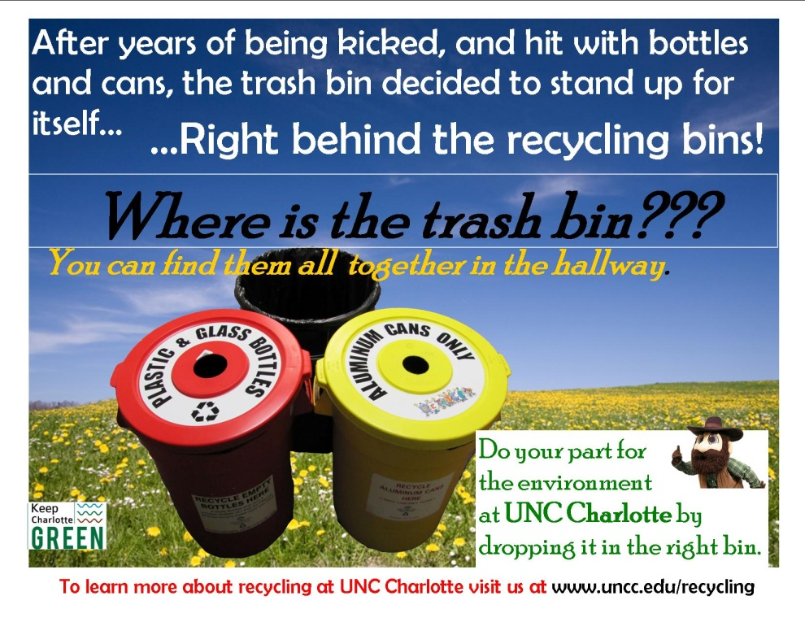

Poster in classrooms after removing the trash bins. ttratrashtbinsbin

After a successful pilot, we now have this program campus wide.

Next: Office Recycling

Due to the success of the classroom trash bin removal, we began to think about office recycling and how a similar change would have the same positive affect. With that, we decided to bring in a smaller trash can.

1. Increased efficiency of Housekeeping staff - Previously, we collected trash in offices three nights per week. Under the new plan, offices are cleaned on Wednesday’s only thus reducing the time needed to enter offices (more than 2600 per week) to check on trash cans. This has allowed our housekeeping staff to focus more of their efforts in common areas, main corridors, and restrooms. Because our office cleaning takes place on one specific day per week, this allows our customers to better understand and see what is being cleaned, and provide feedback to Housekeeping management.

2. Increased recycling – It is estimated that 70% of all material handled by staff on a given day can be recycled. Previously, employees were required to take their recycling to larger bins located in a common area to be collected, while their trash was collected within their offices. Due to convenience, many recyclable materials were being thrown away. This new program has seen an increase in office related recycling by 10% - 15%.

1. Reduced bin cost – The new 3 quart bin cost about 40% less than the previous 28 quart bin. The 28 quart bins are being repurposed as trash cans in common areas throughout campus.
2. Savings on can liners – The mini bin doesn’t require a can liner, saving the university approximately $13,000 per year.

**Characteristics or qualities that make this program or practice different or innovative**

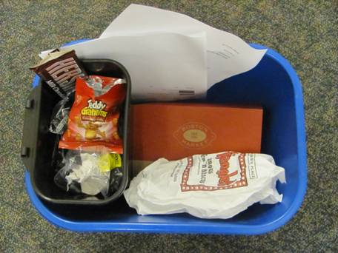By removing the classroom trash bin and distributing the mini bin to staff and faculty throughout campus, it made people re-think their perception of trash and recycling. Instead of recycling being an afterthought, it was in the forefront and the emphasis was put on it. It’s a statement that the majority of material handled in a given day should go in the recycling bin (most of it being paper), and the trash bin, being small or not existing, forced people to think about what they throw away in a given day. We are the only school in North Carolina and one of the few throughout the country that have tried this. Also, with the increase in recycling and decrease in costs, it shows that recycling programs have more than environmental value.

**How this practice can be used by others**

We have shown that this program can be successful. However, it takes support from everyone at the highest levels. Initially, by removing the trash bin from the classroom and reducing the size of the trashcan and requiring staff and students to remove their own waste, it can be viewed as a negative. Fortunately, it doesn’t take long to get the big picture and everyone realizes just how easy the transition is. It is important to have trash cans nearby to minimize the effort that it takes to remove their own trash. In addition to having upper management support, it is critical to educate everyone on this new change. We added posters to all the classrooms where trash bins were once located and had face to face education sessions over the summer with employees from every building on campus to explain the process and answer questions that they had. Seeing the mini trash bin provided some initial shock, however, after giving our presentation and explaining the benefits of the program, we received great support. In summary, these steps are critical to implementing the program:

1. Hold a pilot program. Before taking the program campus wide, we held a pilot program for both changes to gauge results and work through any issues. We completed regular waste audits to prove our hypothesis. This gave us the data we needed to move forward. We then took the program to three buildings on campus for more testing and data.
2. Create a plan to sell upper management and include cost benefits.
3. Meet with building managers and gain their support. They will help get employees to the education sessions.
4. Re-train housekeepers. They may be used to going into offices daily and removing the trash etc. Help them to re-focus where their time will be spent.
5. Sell it to employees. Plan meetings across campus. Explaining the process face to face minimizes any doubts, and because of the cost savings and increased recycling output, the program is more likely to gain support.
6. Set a date to make the changeover. We removed all the classroom bins in one week between sessions and we swapped our trashcans in two days. Promote it as much as possible.

**Demonstration of management involvement and employee commitment**

In order to implement this program, we requested and received permission from every level up to the Board of Trustees. Not having that support would have made this transition impossible. Once we received permission, we turned our attention to the campus community. Holding face to face meetings, usually about thirty minutes twice a day, allowed us to explain the program and the benefits that the university would receive. It allowed us to answer questions, put a face to the program, and ease any concerns that staff and faculty may have. An additional benefit was the opportunity to explain the housekeeping process, educate on our recycling program, and bridge any gaps between employees and our department. At each session, we gave employees an opportunity to address issues that they were having, such as needing to fix or replace carpet, or explain what could be recycled. We addressed each problem personally and corrected it. We feel that this level of customer service helped to create trust, and led to more buy-in and support for the new program.

**Below: Education session**

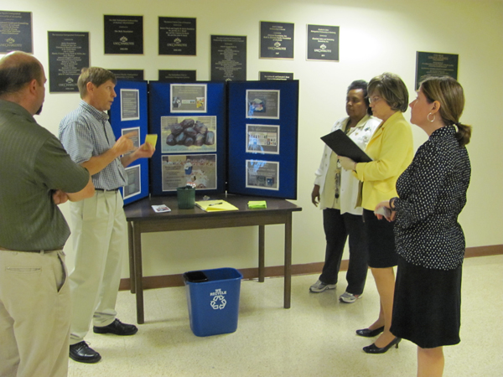

**Documentation of results, analysis, customer feedback, and resulting benchmarks**

We are still documenting results, but waste audits in individual buildings throughout the pilot phase showed an approximately 20% increase in recycling. The latest results of our pilot program comparing fall 2010 to fall 2011 showed an increase of approximately 10 - 15% of recycling (in offices), most consisting of plastic and aluminum. Also, replacement trashcans are 60% of the cost of the old trash cans, and we save about $13,000 in avoidance cost for trash liners. This program will keep about 20,000 trash liners out of the landfill.

For the first few weeks, we issued cards noting what areas were cleaned in the offices that included a space for customer comments on the back. This allowed the customer to be better informed about what was being done in their office, and an opportunity to provide feedback to the housekeeping staff.

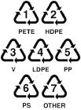MC900303675[1]B**elow: Service cards given to employees after their office was cleaned.**

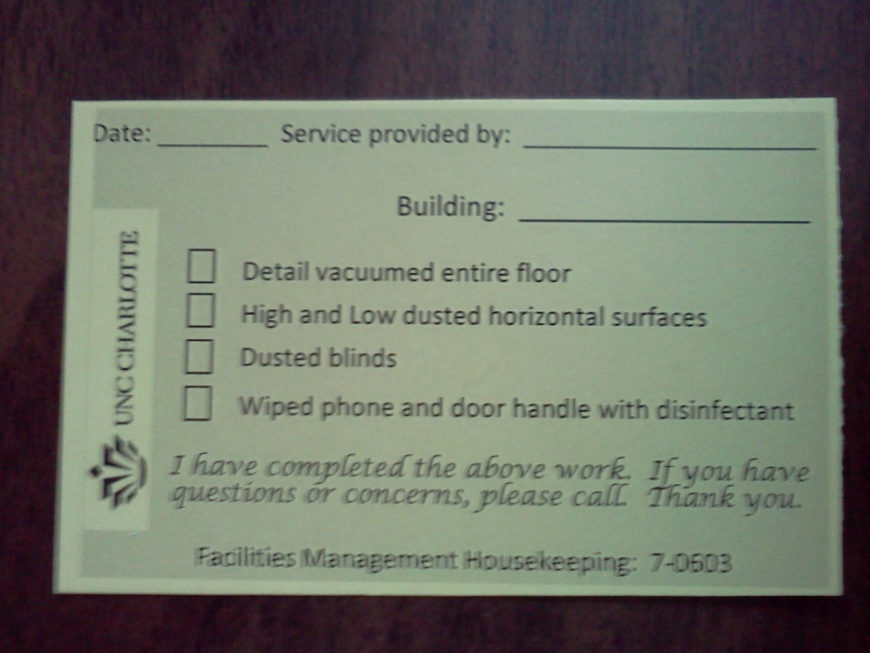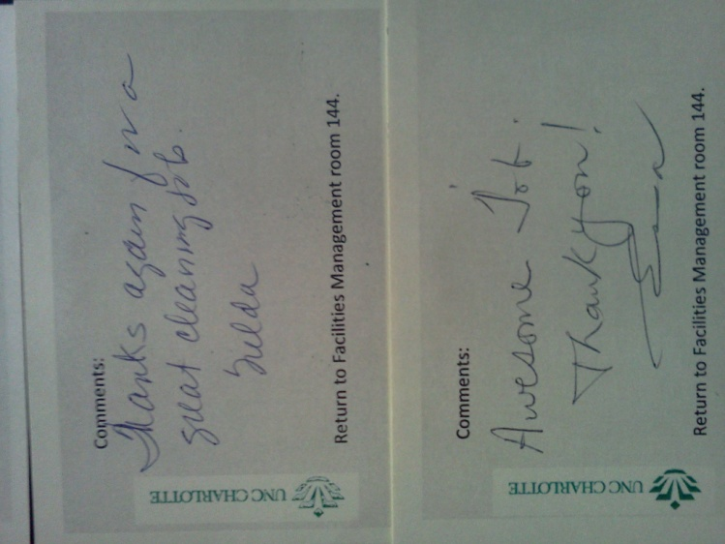

MC900303675[1]B**elow: Sample card that was given on the day employees received their new trash cans.**

**Thanks for helping us “Green” UNC Charlotte**

 In your space, you will be receiving a blue bin for paper recycling, and a small black bin for trash.  Employees are asked to take their recycling to the nearest recycling collection site, and *also* dump their trash from their “mini bin” into the nearest common area trash can.  Common area trash can’s will remain in areas such as conference rooms, reception areas, restrooms, and lobbies and will be emptied daily by Housekeeping.  Recycling bins will be located by the elevators and in the hallway of each floor.

 Housekeeping will clean offices once per week on Wednesday nights only.  We will:  Detail vacuum, high and low dust horizontal and vertical surfaces, dust blinds and wipe your phone and door handle with disinfectant.  Our housekeepers are trained to not move your things, so if you wish for your desk or floor to be cleaned, please ensure that the area is clear before you leave your office on Wednesday.

**Why are we doing this?** 1.  We have been tasked by the UNC Board of Governors to work toward zero waste.  In our pilot programs, we have seen an increase of recycling by 20%.  2.  Due to a lean budget, we are aiming to do more with less.  By cleaning offices only on Wednesdays, we can now direct our focus toward maintaining common areas, floors in high traffic areas, and restrooms.  3.  By using the new mini bin, we will save more than $13,000 per year on trash liners and avoid sending plastic trash liners to the landfill.  The mini bins cost about 40% less than a typical trash can.

 Thanks for your participation in this program.  For Housekeeping or Recycling questions, contact Mike Harris at (704) 231-3128. You can visit the Facilities Management website at facilities.uncc.edu/ for more information about recycling and housekeeping.

**Recycling info is on the back of this card.**

**Below: Service cards**

**Conclusion:**

Removing the trashcans from the classroom and Implementing the “mini bin” was a positive step toward waste reduction, and the acknowledgement of “trash” for our campus community. Often, advances in programs or operations require big changes that are not easily supported. Though, this wasn’t an enormous change, it was a culture change and that is why educating the staff and faculty is so important. Under normal economic circumstances, implementing this program may have been more difficult. However, once put into place, it has shown to be a model that other organizations can emulate, create a positive culture change, and deliver results.